CSOT CyberSec CTF-2

1. 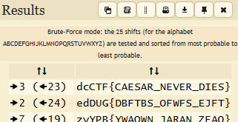Classic Caesar: Caesar bruteforce with dcode
2. 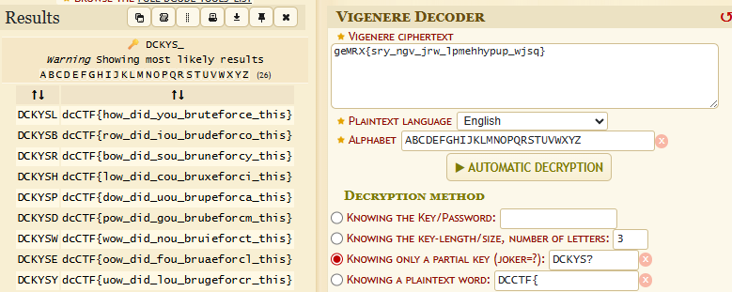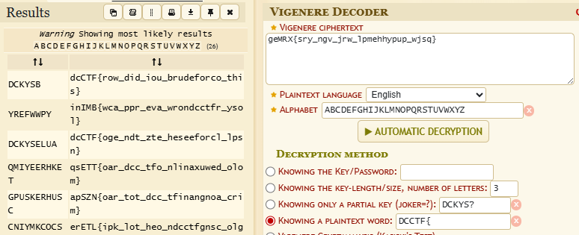Oui Oui Secret: Name suggest vigenere cipher (Felt like it.. ). Done in two steps  
     
     
     
     
     
     
     
     
     
     
     
     
     
     
   Acc to the best result, the B in DCKYSB is wrong. So we do:
3. 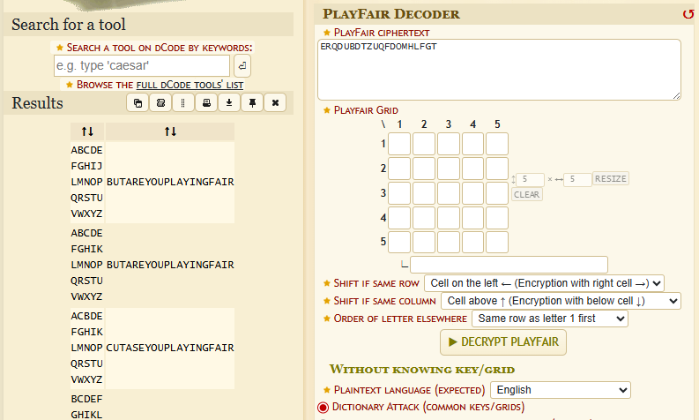Fair Enough: Needed hint. After hint:
4. XOR: After xoring with dcCTF, we get “sandsa”. It is easy to guess that the key is “Sand” repeating
5. Chamaleon Image: First use binwalk:  
     
     
     
     
     
     
     
     
     
   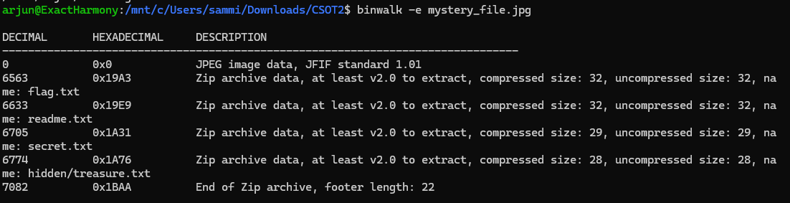The flag is in flag.txt
6. 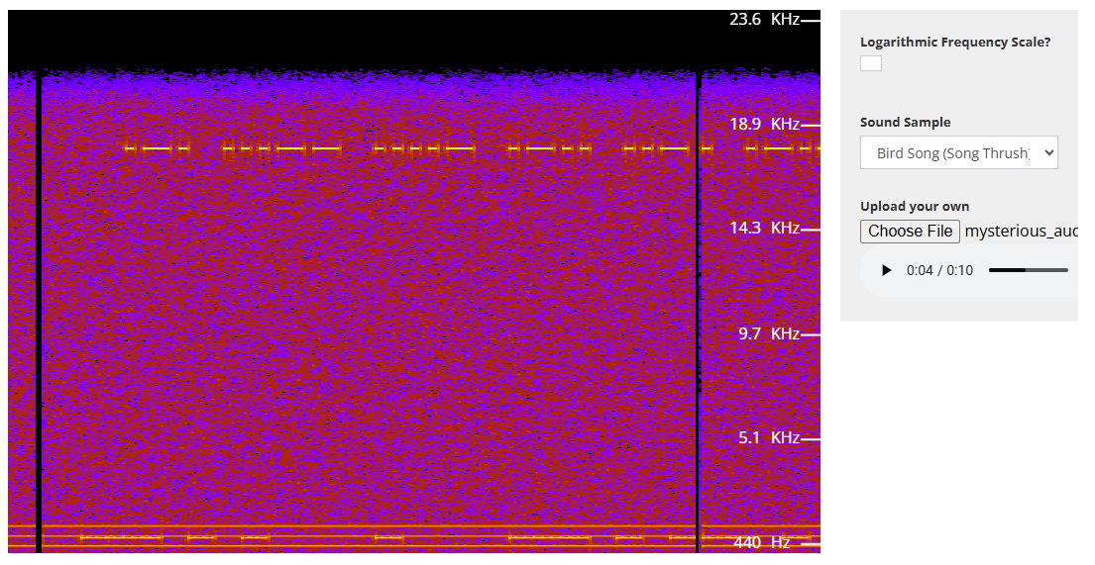Sound of Secrets: We can see the morse code on the spectrogram, and then input it to a morse decoder.
7. 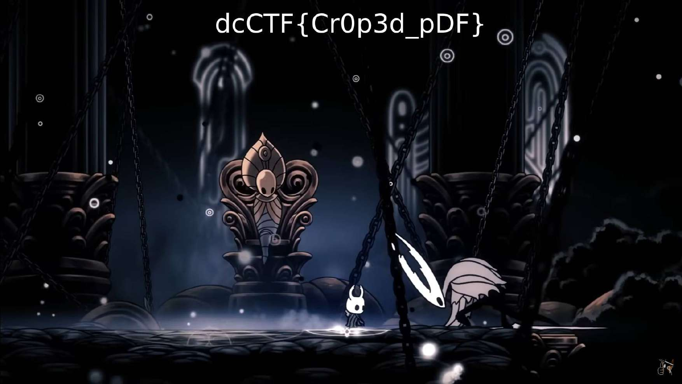Cropped Antics: Found image using pdfimages:
8. 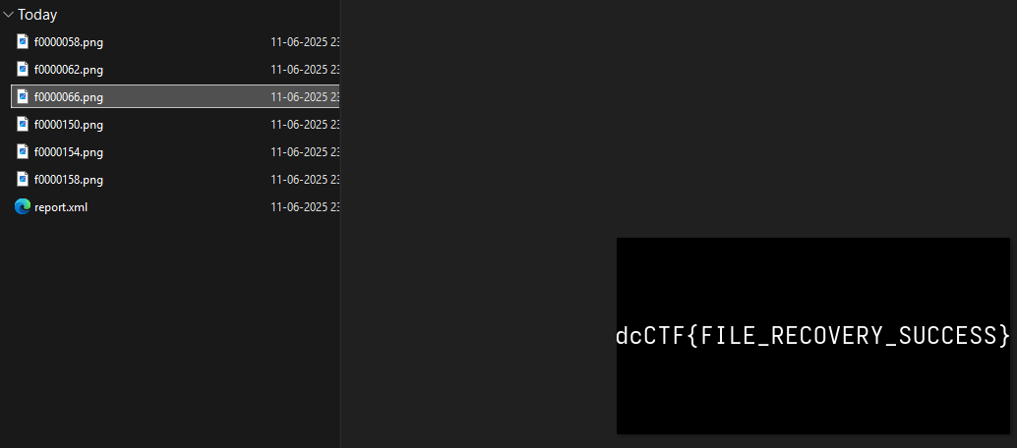Evidence Disk: Photorec:
9. 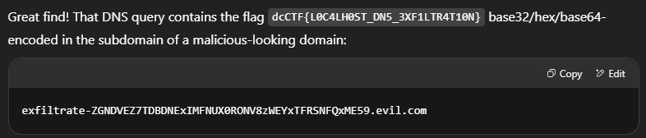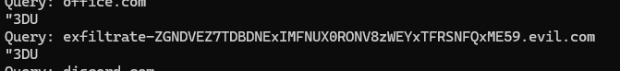Network Intrusion: Happened to see this particular link in strings  
     
     
     
     
     
   I asked ChatGPT how to see data associated with this particular “query”, but it also told me the hidden flag.